**Week 2: Data Visualization Report**

**(Team 33)**

**Submitted By:**

* Joel Abeku (joelchris.jc@gmail.com )
* Maryam Zaman ([maryam30zaman@gmail.com](mailto:maryam30zaman@gmail.com))
* Syed M Qasim Zaidi (smqzaidi725@gmailcom)
* Noor Ul Ain Zahid ([noorulainzahidofficial@gmail.com](mailto:noorulainzahidofficial@gmail.com))
* Tobi Adegbola ([tobiadegbola98@gmail.com](mailto:tobiadegbola98@gmail.com))
* Rafi ([rafi3762@gmail.com](mailto:rafi3762@gmail.com))
* Gloria Akcah ([gloriaackah96@gmail.com](mailto:gloriaackah96@gmail.com))
* Husna Abbas ([husnaabbas328@gmail.com](mailto:husnaabbas328@gmail.com))

|  |
| --- |
| Photo displaying partial image of two pie charts on a canvas-textured page |
| "Visualizing What Works: Making Campaign Data Clear, Powerful, and Easy to Understand"  Data Visualizations |
| |  |  |  | | --- | --- | --- | | Team 33 | 7/21/25 | Visualizations | |

Table of Contents

Introduction 2

Goal Of Week 2 2

Key Visualizations & Insights 2

i. Total Clicks by Campaign 2

ii. Average reach & Impression by Campaign 4

iii. Average Frequency by Campaign 5

iv. Average CPR and CPC by Campaign 6

v. Amount Spent vs ULC (Scatter Plot) 7

vi. CTR vs Frequency (Scatter Plot) 8

vii. CTR & Unique CTR by Campaign 9

viii. Heatmap (CPR by Age & Geography) 10

Poor Performing Compaigns 11

Conclusion 11

# Introduction

In the first week of the Data Visualization Virtual Internship with Excelerate and GlobalShala, our team started looking at Facebook ad campaign data. We checked things like how many people saw the ads, how many clicked, and how much money was spent. Our main goal was to find which ads were not doing well and should be stopped, and we used easy-to-understand charts to show our results.

# Goal Of Week 2

In Week 2, our goal is to learn how to improve and finalize our data visualizations so they clearly communicate our analysis and recommendations. As data analysts, we often create quick and rough visualizations while working with our team. But when it’s time to share our results with others—like managers or clients—we need to make our visuals simpler, clearer, and more professional. This week, we’ll focus on selecting the best charts to support our recommendations and designing them to be easy to understand. We’ll explore helpful techniques like simplifying visuals, highlighting key points, adding notes, using clear labels, and getting inspiration from well-designed examples.

# Key Visualizations & Insights

In the previous week, we created several visualizations to explore and analyze the performance of our ad campaigns. These included charts showing metrics like total reach, engagement, conversion rate, and cost per result. In this week, we focused on refining those visualizations to make them clearer and easier to understand for any audience. We simplified the designs, used direct labeling, added emphasis to key points, and included annotations to highlight important trends. These improvements helped us clearly identify which ads performed well and which ones need to be reviewed or discontinued.

## i. Total Clicks by Campaign

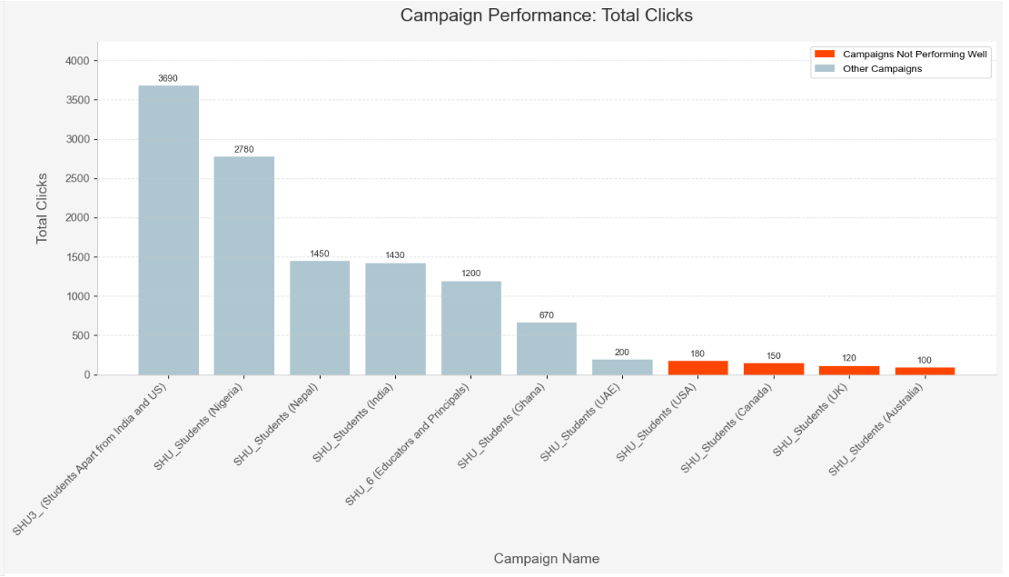

#### **Insight findings:**

|  |  |  |  |
| --- | --- | --- | --- |
| Campaign Name | Country | Total Clicks | Remarks |
| SHU_Students (USA) | USA | 180 | Low performance |
| SHU_Students (Canada) | Canada | 150 | Needs improvement |
| SHU_Students (UK) | UK | 120 | Underperforming |
| SHU_Students (Australia) | Australia | 100 | Lowest clicks among all campaigns |

## ii. Average reach & Impression by Campaign

#### 

#### **Insight findings:**

|  |  |  |  |
| --- | --- | --- | --- |
| Campaign Name | Country | Total Views | Remarks |
| SHU_Students (Canada) | Canada | 4,000 | Low visibility |
| SHU_Students (UK) | UK | 3,500 | Very limited reach |
| SHU_Students (Australia) | Australia | 2,800 | Second lowest overall |
| SHU_Students (USA) | USA | 1,800 | Lowest total views among all campaigns |

## iii. Average Frequency by Campaign

#### 

#### **Insight findings:**

|  |  |  |
| --- | --- | --- |
| Campaign | Avg. Frequency | Observation |
| SHU_Students (USA) | ~1.0 or below | People in the USA saw the ad only once on average — very low exposure. |
| SHU_Students (UK) | ~1.0 or below | The ad is not being shown repeatedly — low chance of remembering or clicking. |
| SHU_Students (Australia) | ~1.0 or below | Similar issue — low repeated exposure leading to poor engagement. |
| SHU_Students (India) | ~1.0 | **Different case** — even with low frequency, this campaign got high views and clicks. This suggests the Indian audience responds well even with just one ad exposure. |

## iv. Average CPR and CPC by Campaign

#### 

#### **Insight findings:**

|  |  |  |  |
| --- | --- | --- | --- |
| Campaign Name | CPR (INR) | CPC (INR) | Status |
| SHU_Students (Australia) | 22.0 | 8.0 | Very high cost |
| SHU_Students (UK) | 10.5 | 6.0 | High cost |
| SHU_Students (UAE) | 9.0 | 4.5 | High cost |
| SHU_Students (Canada) | 7.5 | 5.5 | High cost |
| SHU_Students (USA) | 5.0 | 5.0 | Moderate cost but low reach |

## v. Amount Spent vs ULC (Scatter Plot)

#### 

**Insight findings:**

|  |  |  |  |
| --- | --- | --- | --- |
| Campaign Type | Approx. Amount Spent (INR) | Approx. Unique Link Clicks (ULC) | Performance Note |
| Not Performing Well | ~2350 | ~400 | Very Inefficient: High Spend, Low ULC |
| Not Performing Well | ~950 | ~100 | Weak Performance |
| Not Performing Well | ~850 | ~100 | Weak Performance |
| Not Performing Well | ~800 | ~50 | Weak Performance |

## vi. CTR vs Frequency (Scatter Plot)

#### 

#### **Insight findings:**

|  |  |  |  |
| --- | --- | --- | --- |
| Campaign Name | Average Frequency (Times Ad Seen) | Click-Through Rate (CTR in %) | Performance Note |
| SHU_Students (UK) | ~2.2 | ~2.5 | High Frequency, Low CTR |
| SHU_Students (Australia) | ~3.1 | ~1.8 | High Frequency, Low CTR (even lower than UK) |

## vii. CTR & Unique CTR by Campaign

#### 

#### **Insight findings:**

|  |  |  |  |
| --- | --- | --- | --- |
| Campaign Name | CTR (%) | Unique CTR (%) | Highlighted Status |
| SHU_Students (Australia) | 4.3 | 4.2 | Both CTR & Unique CTR low |
| SHU_Students (UK) | 3.5 | 3.5 | Both CTR & Unique CTR low |
| SHU_Students (UAE) | 2.8 | 2.6 | Both CTR & Unique CTR low |
| SHU_Students (Nepal) | 4.0 | 2.2 | Only Unique CTR low |

## 

## viii. Heatmap (CPR by Age & Geography)

#### 

#### **Insight findings:**

|  |  |  |  |
| --- | --- | --- | --- |
| Country | Age Group | CPR (₹) | Performance Tag |
| UK | 25–34 | 28.40 | Extremely Poor |
| USA | 25–34 | 15.75 | Poor |
| Australia | 25–34 | 12.65 | Poor |
| UAE | 25–34 | 11.11 | Poor |

# Poor Performing Compaigns

These ads use a lot of money but don’t get enough useful clicks. So, they should be stopped to save money and focus on better-performing ads.

|  |  |
| --- | --- |
| Campaign Name | Reason for Discontinuation |
| SHU_Students (Australia) | Highest CPR with very low ULC and low CTR. Also has low reach & clicks. |
| SHU_Students (UK) | Extremely low engagement and very high CPR. |
| SHU_Students (UAE) | Poor return with low ULC and high CPR despite moderate spend. Weak CTR confirms it. Also showed ad fatigue (high frequency, low CTR). |

# Conclusion

One of the most important things we learned from this report is that clear and simple visuals are just as important as the data itself. Even if the data is useful, it won’t help much if people can’t understand it easily. Our charts and graphs should tell a story at a quick glance clear enough for anyone to understand, whether they are experts or not. When people understand the data, they can make better decisions and take the right actions. So in the future, we should focus on making our visuals not just accurate, but also easy, meaningful, and powerful. Good data is not enough we need to make it speak clearly to everyone.